Andree Salvo
Southern New Hampshire University
CYB 300
6-3 Activity
Instructor: Jason Keltner

Create three groups: Human Resources, Finance, and Sales. Create 12 user accounts and place them in one of the three groups. Set the passwords to NewP@$$w0rd
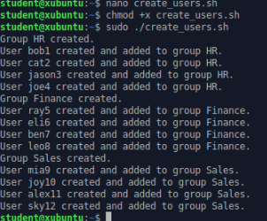
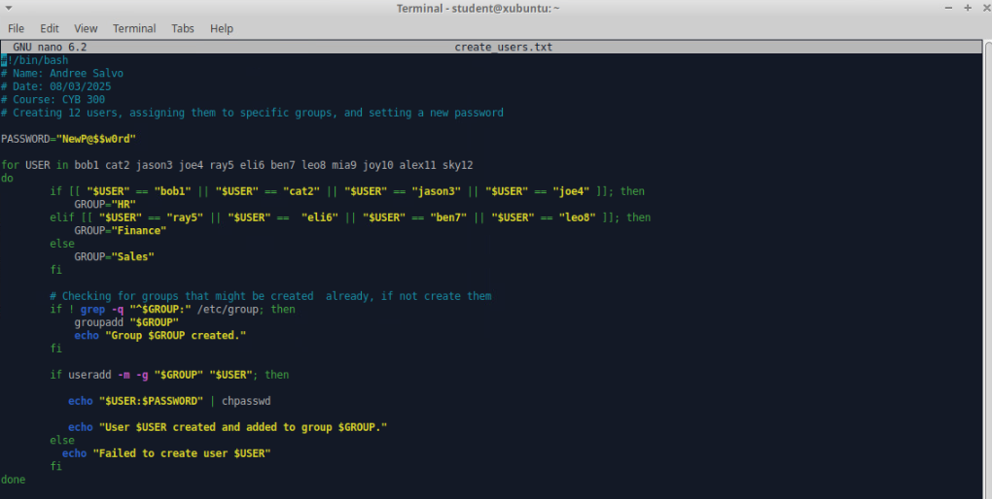

Create a script to back up the /home directory as a compressed tar file to a folder called /backup
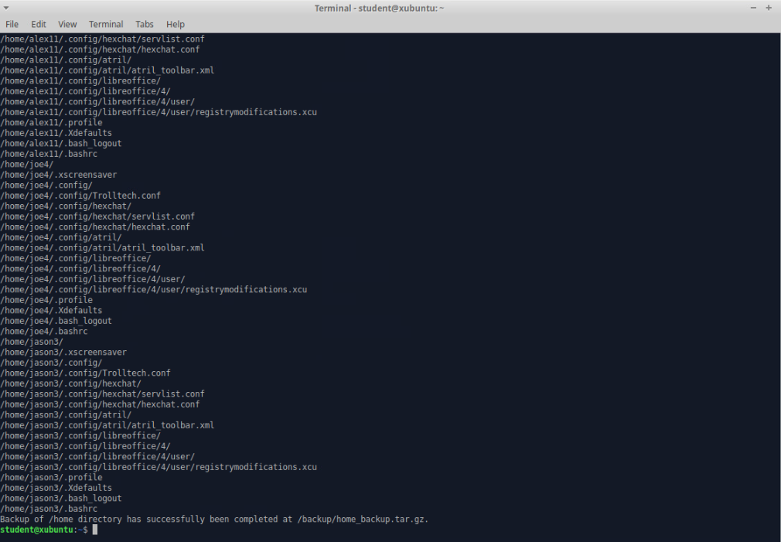
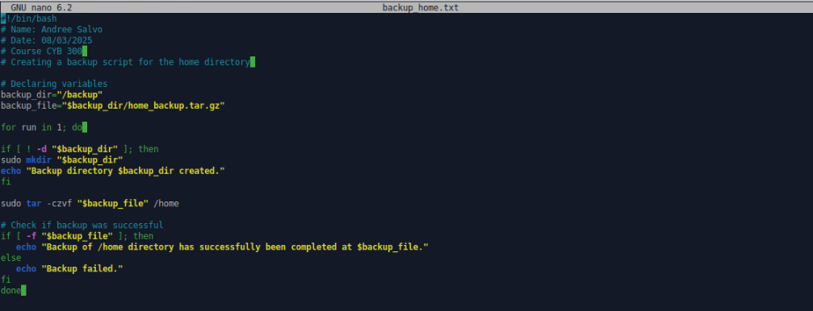

Use the Ping utility to report connections of all IP addresses that end in an odd number in the network, and output them to a text file called ping.txt
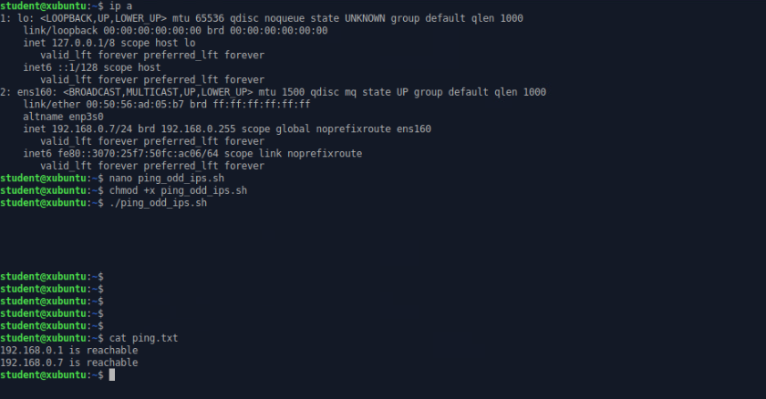
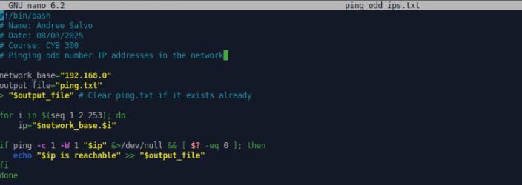

Create a user group named Audit and include all the employees of the HR and Finance organizational units
Note: I mistakenly misspelled “audit” as “Aduit”
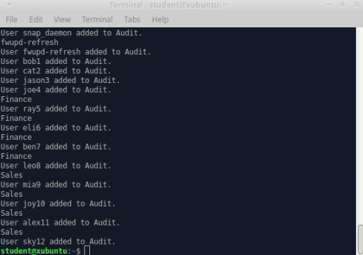
Results
Code
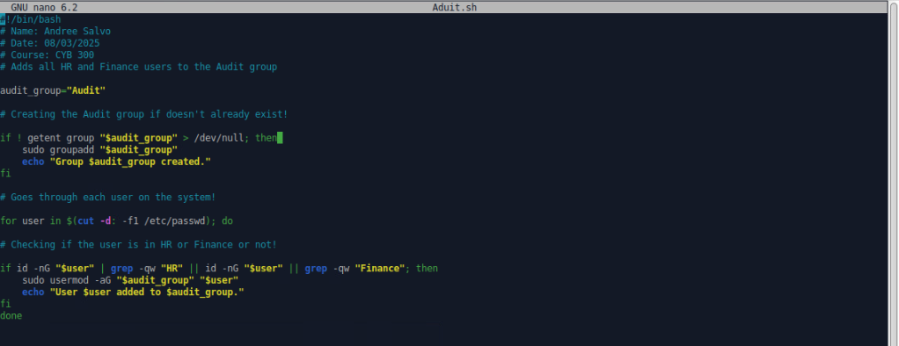

Find all users with inactive and disabled accounts across all organizational units and output the list to a text file named inactive_users.txt
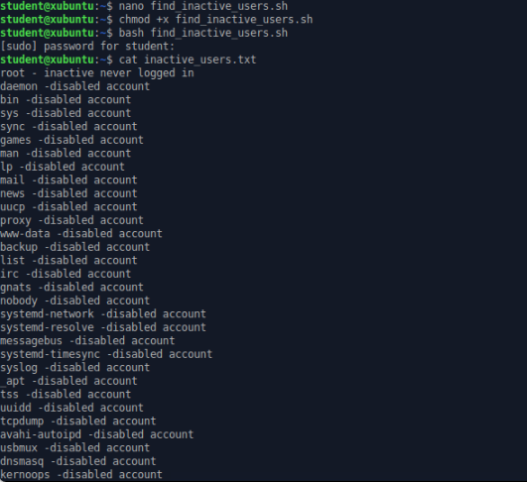
Code:
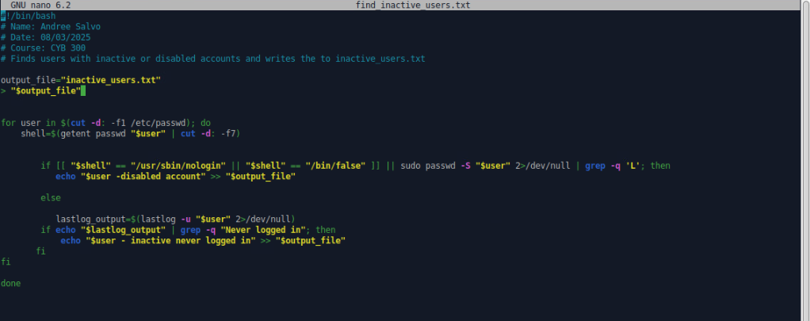

Get a list of all running processes and output the list to a text file named running_processes.txt
